Chapter 14 The Behavior of Gases
Four variables are generally used to describe a gas. The variables and their common units are
- pressure (P) in _____________________
- volume (V) in ________________________
- temperature (T) in _________________________
- (n) the number of _____________________________

___________________ with the inside walls of the raft __________________ that is exerted by the enclosed gas.

If you ________________________ it will ________________________, which is why the gas pressure
__________________________.

Definitions:
- Heat

- Temperature

- Pressure

- Volume

Boyle’s Law (Pressure vs. Volume)
- Pressure and volume are _______________
- Pressure and 1/volume are _______________

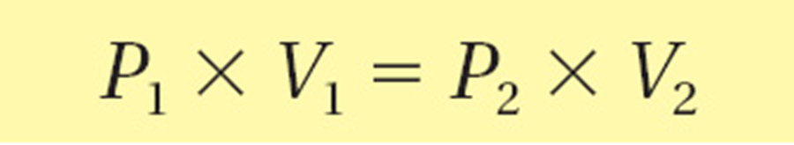

Using Boyle’s Law
A balloon contains 30.0 L of helium gas at 103 kPa. What is the volume of the helium when the balloon rises to an altitude where the pressure is only 25.0 kPa? (Assume that the temperature remains constant.)

Example Calculations:
Boyle’s
- A balloon initially occupies 12.4 L at 1.00 atm. What will be the volume at 0.800 atm?

- A sample of gas expands from 10.0 L to 30.0 L. If the initial pressure was 1140 mm Hg, what is the new pressure?

HW. 419 Problems 7-8
Charles’s Law (temperature vs. volume) states that the volume of a fixed mass of gas is directly proportional to its Kelvin temperature if the pressure is kept constant.
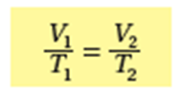

- Temperature and volume are ______________________
- Absolute zero
  - Theoretically,
  - The temperature at which volume of a gas becomes zero when the plot of temperature vs. volume is extrapolated.

Using Charles’s Law
A balloon inﬂated in a room at 24°C has a volume of 4.00 L. The balloon is then heated to a temperature of 58°C. What is the new volume if the pressure remains constant?

Example Calculations:
Charles Law
- Calculate the decrease in temperature when 2.00 L at 20.0°C is compressed to 1.00 L.

- A gas occupies 900.0 mL at a temperature of 27.0°C. What is the volume at 132.0°C?

Gay- Lussac’s Law (Temperature vs. Pressure)

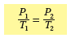
- Temp and pressure are __________________
- Absolute zero
  - The temperature at which the pressure of a gas becomes zero when a plot of pressure versus temperature for a gas is extrapolated
- -273°C = 0 K or K = °C + 273
Example Calculations:
Gay Lussac
- Consider a container with a volume of 22.4 L filled with a gas at 1.00 atm at 273 K. What will be the new pressure if the temperature increases to 298K?

- A container is initially at 47 mm Hg and 77K (liquid nitrogen temperature.) What will the pressure be when the container warms up to room temperature of 25°C?

- A thermometer reads a pressure of 248 Torr at 0.0°C. What is the temperature when the thermometer reads a pressure of 345 Torr?

- Consider a container with a volume of 22.4 L filled with a gas at 1.00 atm at 273 K. What will be the new pressure if the temperature increases to 298K?

- A container is initially at 47 mm Hg and 77K (liquid nitrogen temperature.) What will the pressure be when the container warms up to room temperature of 25°C?
Combined Gas Law
- There is a single expression that combines Boyle’s, Charles’s, and Gay-Lussac’s laws. The combined gas law describes the relationship among the pressure, temperature, and volume of an enclosed gas. The combined gas law allows you to do calculations for situations in which only the amount of gas is constant.

- STP (standard temperature and pressure)
  - T = 273K (which is 0°C)
  - P = 1 atm, 101.3 kPa, 760 mmHg, 760 torr
  - V = 22.4 L (one mole of gas)
- Formula
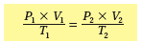

Example:
  - 10.0 cm³ volume of a gas measured 75.6 kPa and 60.0°C is to be corrected to correspond to the volume it would occupy at STP.

Ideal Gas Law
- PV = nRT
  - P =
  - V =
  - n =
  - R =
  - T =
    - Calculate R if pressure is in atm:

- Calculate R if pressure is in kPa:

- Calculate R if pressure is in torr or mm Hg:

Ideal Gas Law Example:
- Calculate the temperature of 0.500 moles of a gas occupying a volume of 20.0 L with a pressure of 99.9 kPa.

- Calculate the moles of a gas occupying a volume of 500.0 mL with a temperature of 25.5°C and a pressure of 755 torr.

Dalton’s law of partial Pressure:
- The total pressure in a container is the sum of the partial pressures of all the gases in the container

- P_{total} = P₁ + P₂ + P₃
- P_{total} = 100 KPa + 250 KPa + 200 KPa = 550 KPa
- Example:
  - Air contains oxygen, carbon dioxide, and trace amounts of other gases. What is the partial pressure of oxygen at 101.3 KPa of total pressure if the partial pressure of nitrogen, carbon dioxide, and other gases are 79.1 KPa, 0.04 KPa, and 0.94 KPa respectively?
    - P_{total} = PO₂ + PN₂ + PCO₂ + POther gases

  - If a gas contains .4 moles oxygen, .3 moles of nitrogen, .2 moles of hydrogen, and .1 moles of argon, what is the partial pressure due to nitrogen?

